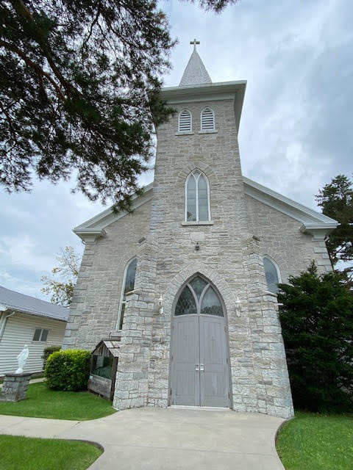 | 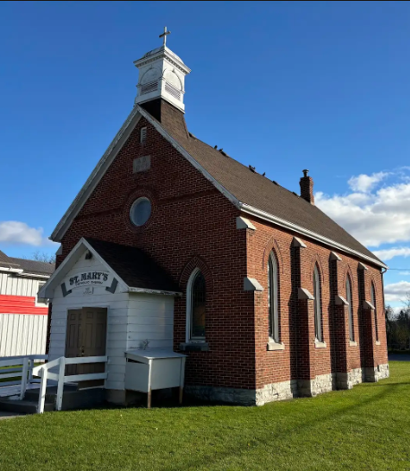

St. Patrick’s Church  3977 Sydenham Rd, Sydenham, ON  K0H 2W0  PASTORAL TEAM  Pastor:  Most Rev. Michael Mulhall,  Archbishop of Kingston  Sunday Masses & Sacraments:  St. Patrick’s: Fr. Sebastian Amato  fr.s.amato@gmail.com  Deacon Michael Winn  mikewinn2001@gmail.com  Parish Administrator:  Jim Hase  baloo@kos.net  Parish Secretary:  Denise Ford  Telephone: 613-376-6695  Email: StPatrick.Railton@archkingston.ca  Parish Website:  www.stpat-stmary-railton-odessa.com |  | St. Mary’s Church – Mission  131 Main Street Odessa, ON  K0H 2HO  Mass Times:  St. Patrick’s Sunday at 11:00 a.m.  St. Mary’s Church Closed until further notice  Sacrament of Reconciliation:  St. Patrick’s: Please see Fr. Amato after Mass on Sunday or call the parish office to make an appointment.  St. Mary’s: Church closed until further notice  Parish Ministries:  St. Patrick’s:  Pastoral Council  Finance Council  Welcome to New Parishioners  St. Patrick's and St. Mary’s welcomes new members to our faith community. Please visit or email the Parish Office to register.
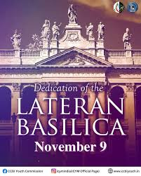  Sunday, November 9th, 2025  The Dedication of the Lateran Basilica  MASS INTENTIONS  St. Mary’s - Church closed until further notice  November 16th St. Patrick’s at 11 a.m.  + Michelle Huntley  OFFERTORY COLLECTIONS  St. Patrick’s Collection $2,514.25  Thank you for your continued generosity.  Monthly Collection:  Priests’ Retirement Fund – November 9th  Food Bank – November 16th  Christmas Flowers – November 30th  The Food Bank Collection is on November 16th. The money collected in St. Patrick’s, Railton goes to the Southern Frontenac Community Services Corporation (SFCSC) food bank in Sydenham that services the South Frontenac area. This collection is in cooperation with the Knights of Columbus Food for Families program. The Knights contribute an extra $100 for every $500 collected locally up to a maximum contribution of $500. Please give generously as the use of food banks is increasing.    ADVENT CHILDREN SESSIONS  Advent is approaching; to prepare our children I am offering 2 sessions. First one November 16th each child will make an advent wreath. Second session each child will make a stocking for Jesus on November 30th. We will start each session at 10:45 a.m. sharp, at the offertory the children will come back into the church with their items to be blessed by Father Amato.  Must registered by November 9th by emailing fitznol@hotmail.com state your child’s name and age.  Anyone interested in sponsoring these 2 sessions to help pay for the supplies please let me know.  Thank you. Paddy Fitzgerald Nolan    CATHOLIC WOMEN’S LEAGUE  The next CWL meeting for November will be held on Sunday November 23rd, and not the 16th at 9:30 a.m.  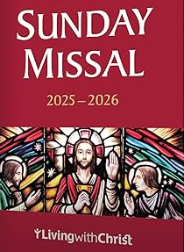  SUNDAY MISSALS  The 2025-2026 Sunday Missals have arrived and are for sale in the parish hall $7 each.  DONATIONS FOR TUK  The October Free Shipping that the CWL has used in previous years is not available to us this season. However, we would still like to send some essential items of the smaller variety & size. These would include — warm socks, underwear, lined work gloves, leggings for children, and toques.  The TUK donation basket is located in the parish hall atop the piano, if you wish to drop off any items of this type. Sister Fay in Tuktoyaktuk has always been overwhelmed with our parish generosity and we hope in this way, to continue our support for our Northern Mission friends.  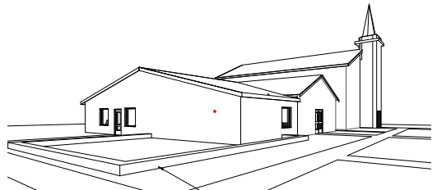  Parish Hall Expansion Fund envelopes.  St. Patrick’s is at present forming a fundraising committee to raise money to build the parish hall expansion. The fundraising campaign will start in early 2026. In the meantime, some people may wish to make a donation before the end of the 2025 tax year in order to reduce their 2025 taxes.  Special goldenrod-coloured envelopes have been printed marked “Parish Hall Expansion Fund.” These envelopes will be at the church entrances. These can be put in the regular collection or taken to the parish office. The donation will be recorded and the amount included in the 2025 tax receipt.  UPCOMING PARISH EVENTS    ST. PATRICK SCHOOL MASS  The next St. Patrick’s School will be on November 12th at 10 a.m. Everyone welcome!    PANCAKE SUNDAY  Knights of Columbus pancake Sunday is on November 30th, 2025 after Mass.  KNIGHTS OF COLUMBUS BINGO  The next bingo will be held on Monday, December 1st in the parish hall at 7:00 p.m. Bring a friend. All are welcome.  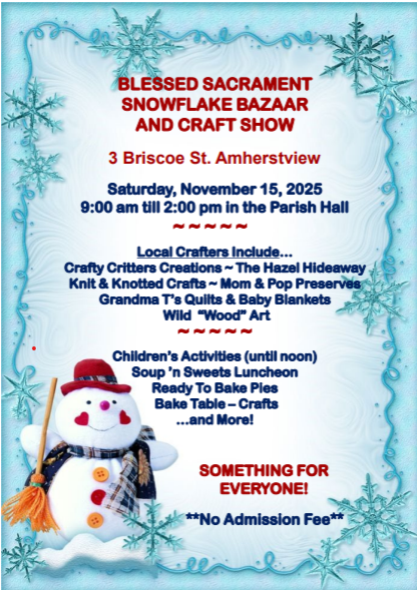 |  | OCTOBER 2025 – FUNDS COLLECTED  St. Patrick’s  Offertory $7,771.75  Renovations & Maintenance Fund $911.90  Fuel for Warmth & Comfort Fund $535.00  Snow Ploughing Fund $10.00  World Mission Sunday $450.00  Needs of the Canadian Church $10.00  Priests’ Retirement Fund $10.00  St. Mary’s  Offertory $60.00  Renovations & Maintenance Fund $20.00  World Mission Sunday $20.00  First Reconciliation and First Holy Communion  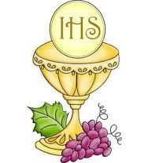  Enrollment Sunday for First Reconciliation / First Holy Communion candidates is Sunday, November 16th, 2025. All registered candidates to attend.  CONFIRMATION    Confirmation parent’s letter and registration form are on the parish website. Mark your calendar. Parent’s meeting dates are November 16th at 12:30 p.m. after Sunday Mass in the church or Tuesday, November 18th at 7 p.m. in the parish hall. You only need to attend one of the meetings. Please bring the registration form and a copy of your child’s baptism certificate to the parent’s meeting. Do not return the registration form to school.    ROSARY GROUP  Our Rosary Group meets every Wednesday morning at 10 a.m. in the parish hall. All are welcome.  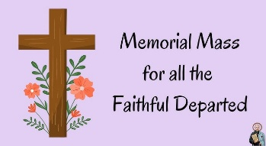  MEMORIAL MASS:  Our annual Memorial Mass will be held on Tuesday, November 11th at 7 p.m. There is a clipboard at the back of the church to list the names of family members that have passed away this year. Each name will be read aloud at the evening Mass.  PRAYERS FOR THOSE WHO ARE ILL  Please remember in your prayers the following:  Stephen Fink, Cathy Dunne, Bev Huff, Carla Jackson, Marlayne Roy, Sally Fink, Jamie Myers, Trudie Thurlby, Connie and Mariano Arruda, Mary Baker, Mary Lapratte, Ashley Thompson, Francine Arsenault, John Beneteau, Graham Dodd, Lloyd Wright, Gary Luptom, Jerome Clair, Darlene Nolan-Dillabough, Sharon Nolan-Conway, Charlie and Veronica Barry.  OUR COMMUNITY  CWL - CHRISTMAS BAZAAR & CRAFT SHOW  Date: Saturday, November 22, 2025  Time: 10 am - 3 pm  Place: St. Paul the Apostle Church,  1111 Taylor Kidd Blvd., Kingston  Come join us for our Christmas Bazaar & Craft Show featuring vendor tables, bling, plants, books & puzzles, Christmas gifts, crafts, bake sale and more!  CHRISTMAS CRAFT SALE  Date: November 30, 2025  Place: St. Francis of Assisi School  Weller Avenue, Kingston  Vendors are welcome to participate. The cost is $25 per spot, and a table and chairs will be provided. To reserve a spot, contact Sandy Murchie at 613-548-3761.You can also email her at orangeladybug99@yahoo.ca  ST. EDWARD’S CWL ANNUAL CHRISTMAS BAZAAR  Date: Saturday, December 6, 2025  Time: 10:00 a.m. – 1:00 p.m.  Place: St. Edward’s School Gymnasium,  51 Bedford Street, Westport  Join us for festive fun at the annual Christmas Bazaar! Enjoy a bake table, an In-House Raffle with great prizes, and our Christmas Raffle featuring:  - 1st Prize: $250 Kudrinko’s gift card  - 2nd Prize: $200 Cove gift card  - 3rd Prize: Esso gift card  A delicious lunch (soup or chili, homemade bun, pie, coffee or tea) will be served from 11:00 a.m. to 1:00 p.m. (or while supplies last) for $10 per person.  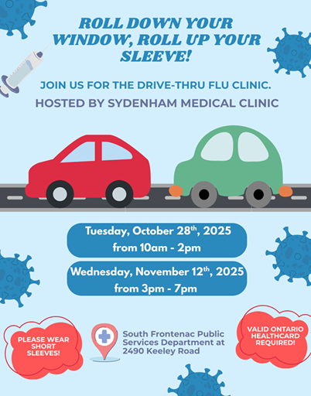
 | St. Patrick’s:  Parish Sacristan Anna Wilson  Liturgical Ministries  Liturgy Committee  Altar Servers Fr. Sebastian Amato  Eucharistic Ministers Fr. Sebastian Amato  Eucharistic Outreach Fred O’Keefe  Ushers/Greeters Sherri Sagriff  Lectors Denise Ford  Choir Kimberly Dowling  Funeral Receptions Jean Myers  St. Patrick’s Cemetery Bill Flynn & Don Murphy  Screening Committee Pauline Hogan  Catechetical Ministries:  Baptism, First Communion, Confirmation & R.C.I.A. Fr. Amato  Service Ministries:  Catholic Women’s League Maryanne Takala  Knights of Columbus Chris Thurgood  Rosary Group |  | St. Mary’s:  Liturgical Ministries  Altar Servers  Eucharistic Ministers  Eucharistic Outreach  Ushers/Greeters  Sacristan Nancy Hamilton  Choir  Funeral Receptions  St. Mary’s Cemetery Maureen Lavigne  Please contact the parish office is you are interested in any of the parish ministries.  Email: StPatrick.Railton@archkingston.ca  Phone: 613-376-6695    Find the latest event updates on the archdiocesan website at: romancatholic.kingston.on.ca/calendar

